**1. Install WinSCP**

- Visit download page: https://winscp.net/eng/download.php

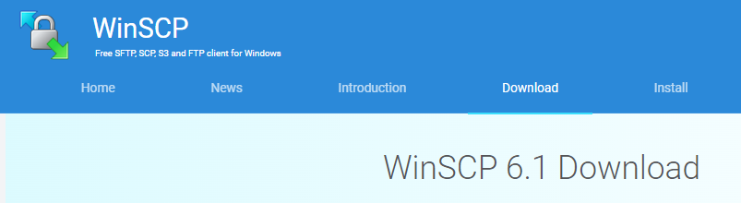

- Click download <WinSCP-6.1.2-Setup.exe>



- Install

**2. Connect to the File Server**

- make a new connection

IP: 192.168.22.1, PORT: 22, ID: ntu, Password: ntu1234

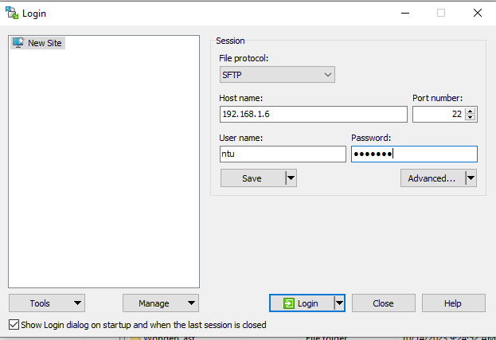

**3. Download Files**

- Download 7 files for week1

